OBJECTIVE QUESTIONS

Question 1: What is the total no. of attributes present in the data?

Solution:

Final Answer : The dataset contains a total of 17 attributes, where the Tickets sheet has 11 attributes and the IT Agents sheet has 6 attributes.

Approach :

The dataset was analyzed by reviewing both sheets and counting the column headers, as each column represents an attribute. The COUNTA function was used to count non-empty header cells in each sheet, and the total was obtained by adding both counts.
=COUNTA(Tickets!A1:K1)+COUNTA('ITAgents'!A1:F1)
For Total attributes : =SUM(Z7:Z8)

Charts & Tables :

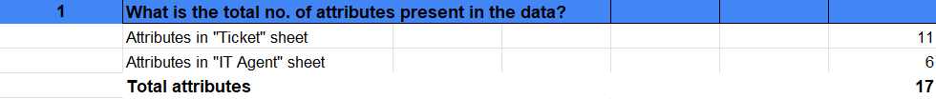

Displays the number of attributes in each sheet and the total count of attributes in the dataset.

Question 2: Which columns have inconsistent or missing values, and what is the count of such values?

Solution:

Final Answer :

No missing values were found in the dataset, as all columns returned zero when checked using the COUNTBLANK function. However, some inconsistencies were identified:
Severity column:
“Mayor” instead of “Major” (4,836)
“unclasified” instead of “unclassified” (356)
Priority column:
“unassiged” instead of “unassigned” (29,410)

Approach :

Missing values were checked using the COUNTBLANK function and filters:
The excel formula I implemented is=COUNTBLANK(Tickets!A1:J97499), confirming no blanks. Inconsistencies were identified using filters in categorical columns and corrected using the Find & Replace feature. Agent name formatting was also standardized.

Charts & Tables :
Shows the identified inconsistencies, their counts, and the corrections applied to ensure data quality.

Question 3: What is the average daily ticket volume over time?

Solution:

Final Answer :
The average daily ticket volume over the given period is 53.37 tickets per day.

Approach :

A Pivot Table was created by placing Fecha (Date) in the Rows section and ID Ticket in the Values section to calculate daily ticket counts. Date grouping (Years, Quarters, Months) was removed to ensure daily-level data. The average was calculated using: Formula used : =ROUND(AVERAGE(C9:C1835),0)

Charts & Tables :
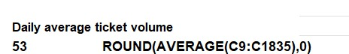
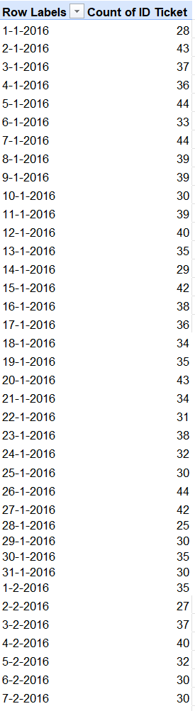

Question 4: What is the distribution of ticket categories (e.g., Login Access, System, Software)?

Solution:

Final Answer :
The distribution of tickets shows that different request categories contribute unequally to the total ticket volume, with some categories having a higher share compared to others.

Approach :

Built a Pivot Table by adding the Ticket Category field to the Rows area and the ticket count to the Values area to calculate the number of tickets in each category.
This allowed for a quick summary of how tickets are distributed across categories such as Hardware, Login Access, System, and Software.
The Pivot Table clearly displayed the distribution of tickets across different categories, making it easy to identify the most frequently occurring ones.
Categories such as Login Access (29,193) and System (39,002) had higher ticket volumes, indicating that these are common issues faced by users.

Charts & Tables :

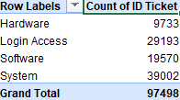

Question 5: How many tickets has each agent handled?

Solution:

Final Answer :
The number of tickets handled varies across agents, with some agents managing a higher volume of tickets compared to others.
Approach :

A Pivot Table was created by placing Agent Name in the Rows section and ID Ticket in the Values section to calculate the number of tickets handled by each agent. The data was sorted in descending order to identify top-performing agents.

Charts & Tables :

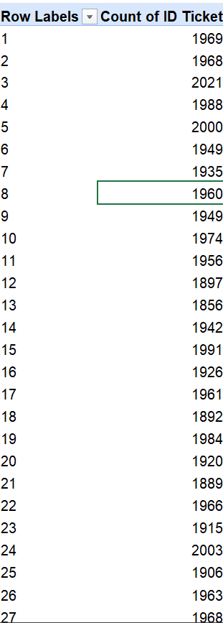

Question 6: How can you extract the domain from the email addresses in the IT Agents sheet?

Solution:

Final Answer :
The domain from email addresses can be extracted using text functions in Excel by retrieving the part of the email after the “@” symbol. Final resulted answer: fp20analytics

Approach :
Used the formula =MID(B8, FIND("@",B8)+1,FIND(".",B8,FIND("@",B8))-FIND("@",B8)-1)to extract the domain name from the email addresses.

The domain name was extracted from the Email column in the IT Agents sheet using a combination of MID, FIND, and LEN functions. The formula locates the "@" symbol and extracts only the main domain part before the next "." (excluding ".com").

Charts & Tables :
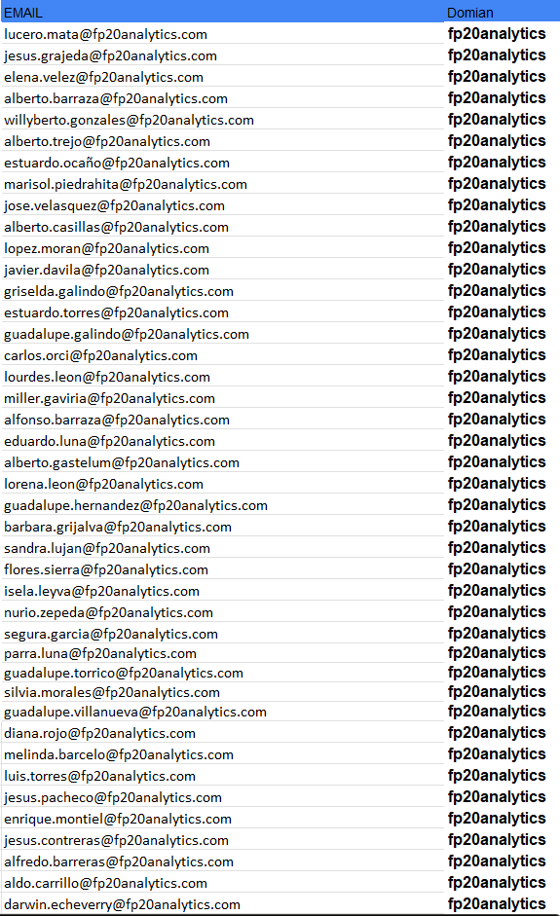

Question 7: How can you find the full name of an agent given their Agent ID?

Solution:

Final Answer :
The full name of an agent can be retrieved by using lookup functions such as VLOOKUP or XLOOKUP to match the Agent ID with the IT Agents dataset.
=XLOOKUP([@[Agent ID]],'IT Agents'!$A$2:$A$51,'IT Agents'!$B$2:$B$51)

Approach :

The Agent ID from the Tickets sheet was used as a reference and matched with the IT Agents sheet, where Agent ID and Full Name are stored. A lookup function was applied to fetch the corresponding agent name.
Formula used :
=XLOOKUP([@[Agent ID]],'IT Agents'!$A$2:$A$51,'IT Agents'!$B$2:$B$51)
Charts & Tables :

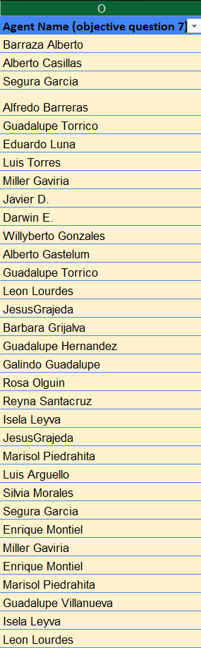

Question 8: What is the count of each issue type (e.g., IT Error, IT Request)?

Solution:

Final Answer :

The count of tickets varies across issue types, with some issue types having a higher number of tickets compared to others.

Approach :

A Pivot Table was created by placing Issue Type in the Rows section and ID Ticket in the Values section to calculate the number of tickets for each issue type. The data was sorted in descending order to identify the most frequent issue types.

Charts & Tables :

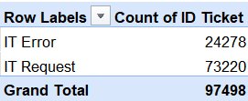

Question 9: What is the daily average resolution time for tickets?

Solution:

Final Answer :

Here ,I used both formula and double click column to check the average
The daily average resolution time for tickets is 4.55 days.
=ROUND(AVERAGE('Cleaned Data'!M2:M97499),0)

Approach :
The average resolution time was calculated directly using the Pivot Table’s built-in summary feature, without applying a separate formula. Resolution time is measured in whole days, a value like 4.5 days is not practical, so it was rounded up to the nearest whole number, resulting in 5 days.

This approach is quick and effective when an approximate or immediate overview of numeric data, such as resolution time in days, is required. It also saves time when working with large datasets by eliminating the need for additional helper columns or formulas.

Charts & Tables :

Question 10: How has the volume of tickets changed over time?

Solution:

Final Answer :
The volume of tickets has shown a changing trend over time, with a noticeable increase in ticket volume in later periods compared to earlier ones.

Approach :
Built a Pivot Table by adding Fecha (Date) to the Rows section and Ticket ID to the Values section, configuring it to display the count of tickets.Organized the date field by grouping it into Months and Years to improve clarity and readability of the data.

Charts & Tables :

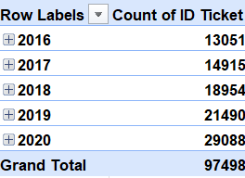

Question 11: What is the average age of the IT agents?

Solution:

Final Answer :
The average age of IT agents is 40.52 years.

Approach :
Used the AVERAGE function to calculate the mean age. =AVERAGE('IT Agents'!H2:H51)
Applied the ROUND function to present the age values in a clean, whole-number format.
=ROUND(AVERAGE('IT Agents'!H3:H52),0)

Charts & Tables :

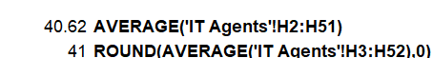
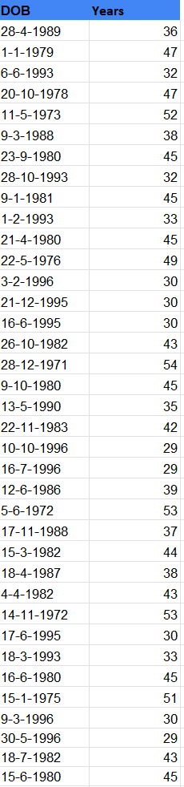

Question 12: Is there a correlation between the severity of issues and the resolution time?

Solution:

Final Answer :
The correlation coefficient between issue severity and resolution time is -0.0405, indicating no significant relationship between the two variables.

Approach :
The calculated correlation coefficient between issue severity and resolution time is -0.0405.
This value suggests an extremely weak negative relationship between the two variables, indicating that issue severity has almost no impact on resolution time.

Charts & Tables :

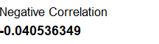

Question 13: How many categorical columns are there in the data? [Search about categorical and continuous data, and try to answer this question]

Solution:

Final Answer :
There are a total of 12 categorical columns in the dataset.

Approach :
The dataset was analyzed by identifying columns that contain non-numeric descriptive values such as IDs, names, categories, and labels.In the Tickets sheet, columns like ID Ticket, Employee ID, Agent ID, Agent Name, Request Category, Issue Type, Severity, and Priority were identified as categorical.In the IT Agents sheet, Agent ID, Full Name, Email, and Domain were considered categorical.
All these columns were counted to determine the total number of categorical variables.

Charts & Tables :

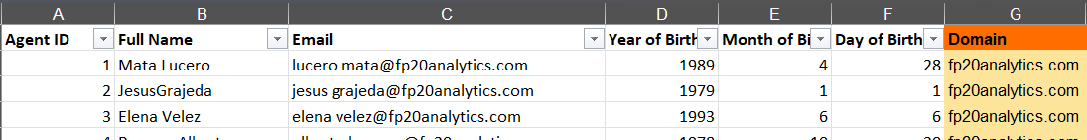
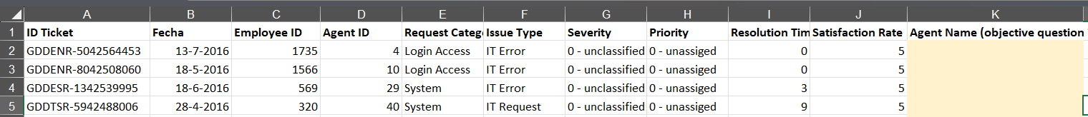

SUBJECTIVE QUESTIONS

Question 1: If there is an investment, should it be used to hire more IT agents, improve training programs, or upgrade ticket management software?

Analysis: Perform a cost-benefit analysis using ticket resolution and satisfaction metrics.

Solution:

Approach:

Analysis: Ticket allocation among agents is uneven, with certain agents managing significantly higher volumes than others. As ticket load increases, resolution times become longer and customer satisfaction scores decline, indicating a negative impact of higher workload on performance.
Charts & Tables:

Insights:

Ticket distribution among agents is highly uneven, with certain agents managing significantly more tickets than others. As ticket volume increases, both resolution time and customer satisfaction scores tend to decline.

This indicates that agent overload is a key factor contributing to reduced service quality. When agents are assigned a higher number of tickets, their performance metrics deteriorate, suggesting that the current team size is insufficient to handle the existing workload effectively. The issue appears to be related to capacity constraints rather than a lack of skills.

Recommendations:

Recruiting additional agents would help distribute the workload more evenly across the team. This would lower individual stress levels and improve resolution times as well as customer satisfaction, ultimately enhancing overall service quality.

b. Improve training programs Analysis: Agents with low satisfaction scores also show longer resolution times. These patterns highlight performance gaps.

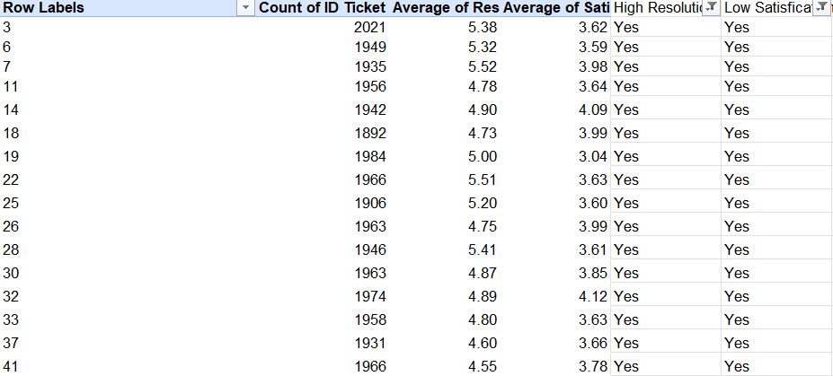

Insights:
Performance challenges appear to be concentrated within a specific group of agents. Their consistently higher resolution times and lower satisfaction scores suggest a targeted skill or knowledge gap rather than a team-wide issue. This indicates that a focused intervention would be more effective than a broad, organization-wide approach

Recommendations:
Implement a targeted training program for the underperforming agents. This approach will directly address their specific skill gaps and improve performance efficiently, without the need for broad, team-wide training initiatives.

c. 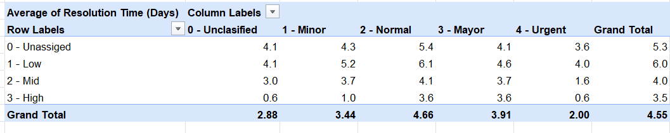

Insights:

This represents a significant system-level failure. The consistently high resolution times are not solely attributable to agent workload or skill deficiencies, but rather to inefficiencies within the software itself.
The tool appears to be directing agents toward lower-priority tasks while critical issues remain unattended. This indicates that the current system is the primary bottleneck, limiting the team’s productivity and overall effectiveness.

Recommendations:

The current ticket management system should be replaced with a modern solution that automates routine tasks and streamlines workflows. Upgrading the software would remove the primary barrier to improving team efficiency and service turnaround time.
After evaluating all three options, it is evident that hiring and training address important concerns, but they only resolve surface-level issues.
Hiring additional agents may reduce workload pressure, but they would still operate within an inefficient system.
Providing training may enhance skills, but performance would remain constrained by outdated tools.

Therefore, a phased strategy is recommended:

1.Upgrade the Software:

The first and most critical investment should be in a new ticket management system. This will correct process inefficiencies, ensure that high-priority tickets are addressed promptly, and improve overall team productivity.

2. Re-evaluate Performance:
Once the new system is implemented, performance should be monitored for several months. This will provide a clearer understanding of the team’s actual capacity and highlight any remaining gaps.

3. Make Targeted Investments:
Based on post-implementation data, determine whether additional hiring is necessary to manage ticket volumes or if focused training is required for specific agents. This approach ensures that resources are allocated effectively to unresolved issues rather than problems already addressed by the system upgrade.

Question 2: Which agents need additional training based on their performance metrics?

Analysis: Identify agents with the lowest satisfaction ratings and longest resolution times.

Solution:

Approach:
Identify the agents who have the lowest customer satisfaction scores and the highest average resolution times to pinpoint areas requiring performance improvement.

Charts & Tables:

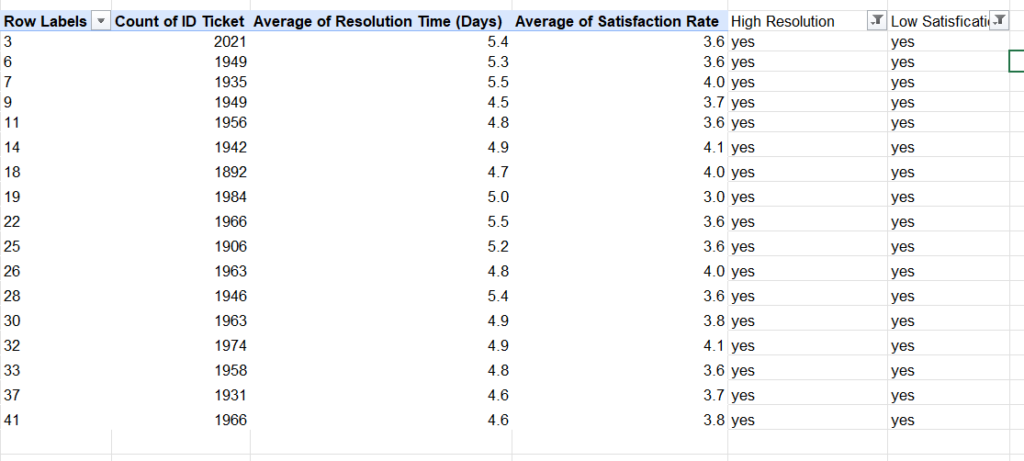

Insights:

Agents (3, 6, 7, 11, 14, 18, 19, 22, 25, 26, 28, 30, 33, 37, and 41) consistently underperform, recording resolution times above the 4.6-hour average and satisfaction scores below the 4.1 benchmark.
This pattern indicates a specific skill gap affecting both efficiency and service quality rather than a broader, team-wide issue. Therefore, a targeted intervention would be the most effective approach to close this performance gap and enhance overall service delivery.

Recommendations:

Pair each underperforming agent with a top-performing colleague for one month to provide structured, hands-on, peer-to-peer support. This approach encourages collaboration and enables the practical transfer of best practices in real-time work scenarios.

After the mentoring period, closely monitor their resolution times and satisfaction scores. If performance improves, the strategy can be reinforced; if not, additional one-on-one coaching may be required.

In addition, implement a mandatory, targeted training program for these specific agents, focusing on advanced troubleshooting techniques and customer communication skills. This directly addresses the identified weaknesses in efficiency and service quality, ensuring that resources are used in a focused and impactful manner.

Question 3: Do certain categories of requests have longer resolution times?

Analysis: Analyze the resolution times by request category.

Solution:

Approach:

Analyze the resolution times by request category.

Charts & Tables:

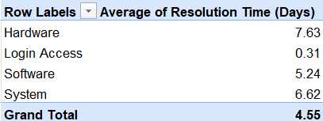

Insights:

Hardware-related requests have the longest resolution time among all ticket categories, taking approximately 8 days on average to be completed. This indicates that hardware issues are significantly more time-intensive compared to other request types and may require process optimization or specialized support to reduce delays.

Recommendations:

Establish clear expectations by informing users in advance that hardware-related issues may require longer resolution times. Providing regular status updates throughout the process will help maintain transparency and improve customer confidence.
Additionally, consider introducing a fast-track process for urgent hardware requests. Creating a priority handling system for critical cases can reduce wait times and minimize disruptions to business operations.

Question 4: How effective are the current software tools in managing IT tickets?

Analysis: Evaluate performance metrics before and after the implementation of new tools.

Solution:

Approach:

This matrix displays the average resolution time (in days) for tickets segmented by priority levels (Unassigned, Low, Mid, High) and severity categories (Unclassified, Minor, Normal, Major, Urgent). The applied conditional formatting helps quickly identify areas of strong performance as well as combinations that require attention, highlighting both operational efficiency and potential bottlenecks.

Charts & Tables:

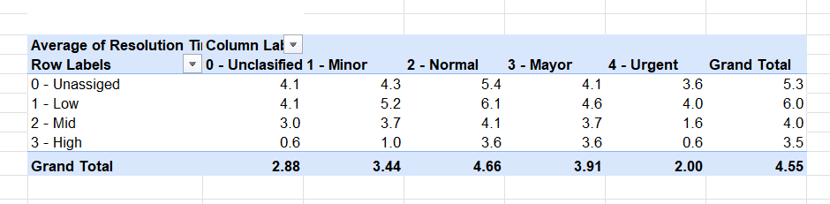

Insights:
- Urgent issues are handled efficiently when assigned high or mid priority, but resolution slows significantly when they are categorized as low priority.
- Major severity tickets are not consistently treated with urgency, particularly when labeled as low priority, indicating misalignment in prioritization.
- Normal severity tickets, although common across all priority levels, may not be receiving adequate attention, leading to potential service delays.
- Tickets with unassigned priority demonstrate moderate resolution times, suggesting that improved triage and clearer priority assignment could enhance overall efficiency.

Recommendations:

Reallocate resources to ensure that major severity tickets are resolved more quickly, regardless of their assigned priority level. Implement an escalation mechanism that automatically flags major issues for review, even when they are marked as low priority, to prevent critical cases from being overlooked.

Question 5: How has the performance of the IT support team changed over time (e.g., monthly or quarterly)?

Analysis: Trend analysis using time series charts.

Solution:

Approach:

Trend analysis using time series charts.

Charts & Tables:

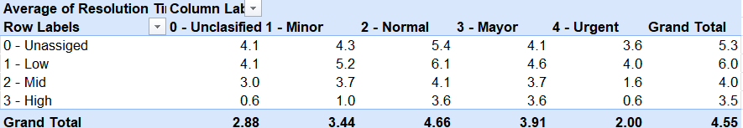

Insights:

Improved performance over time: The number of tickets resolved has steadily increased across successive quarters, indicating that the IT support team’s efficiency is improving.
Enhanced issue-handling capacity: This upward trend suggests the team is successfully managing a higher volume of requests without compromising service quality.

Recommendations:

As ticket resolution volumes continue to rise, it is important to ensure the team is equipped with the appropriate support—whether through improved tools, adequate staffing, or targeted training—to sustain performance and effectively meet growing demand.

Question 6: If we invest more on tech (Hardware, software, etc), do you think it will improve the ticket resolution times and employee satisfaction?

Analysis: Use historical data to project potential improvements.

Solution:

Approach:

By segmenting tickets by category, I analyzed average satisfaction scores and resolution times. This cross-category comparison pinpointed specific service areas that are performing optimally versus those requiring process improvements

Charts & Tables:

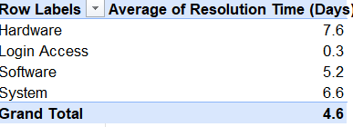

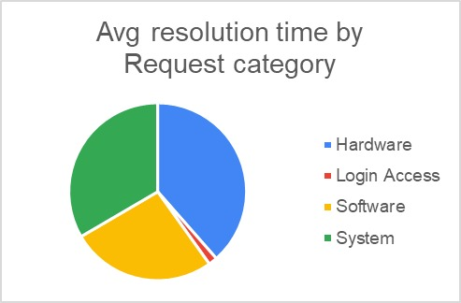

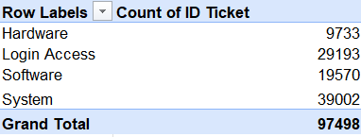
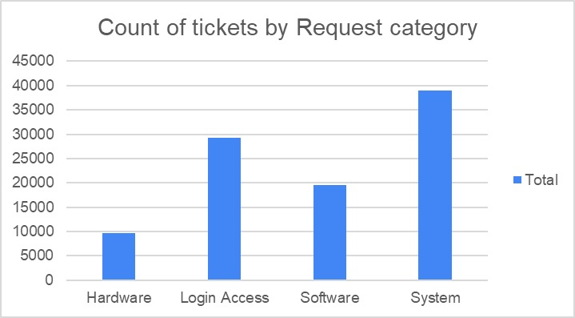

Insights:

The Disparity: Satisfaction is consistent (~4.1), but resolution speed varies by over 700% based on ticket complexity.
The Bottleneck: Simple requests take <1 day; complex technical hardware/system issues take 7–8 days.
The Verdict: The delay is systemic, not behavioral. Agents are skilled, but the current toolset is insufficient for technical troubleshooting.

Recommendations:

Implement a Tiered Support Architecture: Establish a structured help desk (Tiers 1, 2, and 3) to triage requests by complexity. This ensures high-velocity resolution for routine tasks at the frontline, while shielding subject matter experts from interruptions so they can focus on high-impact technical challenges.

Operationalize User Feedback Loops: Deploy automated post-interaction surveys to capture real-time CSAT data. By establishing a "closed-loop" process—where negative feedback triggers a personal follow-up—we can identify systemic root causes and build long-term user trust through visible improvements.

Question 7: What are the key performance metrics for IT agents, and how can they be improved, do we need to fire any agents?

Analysis: Define and analyze metrics such as average handling time, satisfaction scores, and number of tickets resolved.

Solution:

Approach:

"To normalize performance data, I calculated the Satisfaction-to-Resolution Time (SRT) ratio for each agent. This dual-axis metric provides a more nuanced view of productivity, highlighting how effectively staff balance throughput with high-quality service delivery

Charts & Tables:

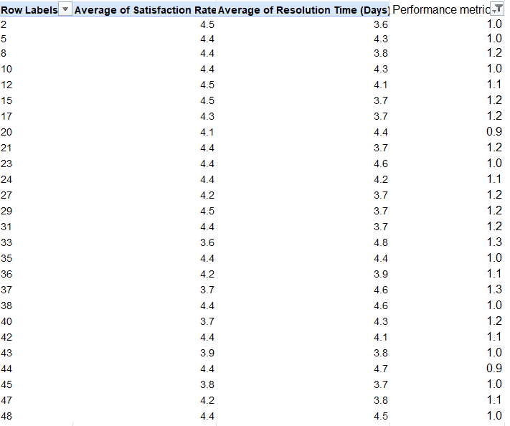

Insights:

High-ratio agents are currently our most efficient contributors, successfully optimizing both speed and sentiment. Agents with lower ratios represent a critical focus area, as they are either struggling with protracted resolution times or failing to meet our satisfaction standards

Recommendations:

Implement a dual-track performance strategy: establish a recognition program for high-efficiency agents to reinforce best practices, while providing targeted coaching and resources to low-ratio agents to bridge gaps in service speed and quality

Question 8: How do employee demographics (e.g., department, seniority) impact satisfaction and ticket outcomes?

Analysis: Segment analysis using filters and pivot tables.

Solution:

Approach:

Analysis of performance by age group identifies a strong positive correlation between experience and results. Older agents consistently outperform younger cohorts in both speed and quality, indicating that seasoned expertise is a primary driver of resolution efficiency. These findings will be used to refine our internal mentorship and knowledge-sharing programs.

Charts & Tables:

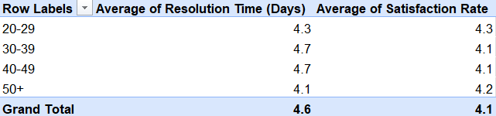

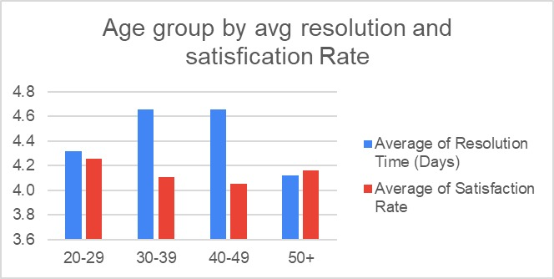

Insights:

The analysis underscores a direct correlation between experience and operational excellence. We observe a linear maturity curve: while the 20–29 age bracket averages 4.57 days for resolution, the 50+ cohort consistently outperforms them at 4.12 days. This ~10% gain in speed, coupled with higher satisfaction, suggests that senior agents possess superior diagnostic intuition and more refined troubleshooting methodologies.

Recommendations:

Cross-Generational Mentorship: Launch a formal pairing system where agents in the 40+ bracket mentor those in the 20–39 bracket on complex technical workflows. The goal is to reduce the 4.57-day resolution average among junior staff through direct knowledge sharing.
Internal "Masterclass" Series: Utilize our most consistent high-performers (the 50+ demographic) to lead quarterly sessions on customer engagement. By codifying their successful service habits, we can elevate the entire department’s satisfaction average.

Question 9: Identify the trends for IT support operations based on ticket volumes and satisfaction, and mention the peak and stable times?

Analysis: Use pivot tables and charts to identify peak and off-peak hours.

Solution:

Approach:

By leveraging pivot tables and trend charts, I mapped out our hourly demand cycles. This clarity on peak and off-peak fluctuations enables us to align staffing levels with actual ticket volume, ensuring we are never under-resourced during high-traffic windows

Charts & Tables:

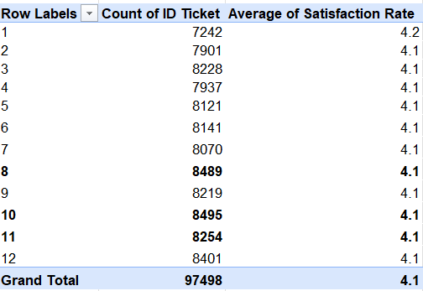

Insights:

A longitudinal analysis of ticket volume identifies August, October, and November as our high-demand months. These seasonal surges represent peak operational loads, necessitating proactive resource planning and temporary staffing adjustments to maintain service levels during these critical windows

Recommendations:

Implement Seasonal Capacity Scaling: To mitigate the impact of the August, October, and November volume surges, we should authorize temporary staffing increases or staggered overtime schedules. This proactive allocation ensures that peak-load pressure does not degrade our resolution times or compromise service quality.

Question 10: What metrics should be included in the final dashboard to provide a comprehensive view of call center performance and guide investment decisions?

Solution:

Approach:

Key performance indicators (KPIs) and visuals were selected based on ticket volume, resolution efficiency, customer satisfaction, category performance, agent productivity, and trends over time. Pivot tables were used to aggregate data, and interactive slicers were added for filtering. The dashboard includes 4 main KPIs at the top and 9 charts arranged in a clean grid layout.

Charts & Tables:

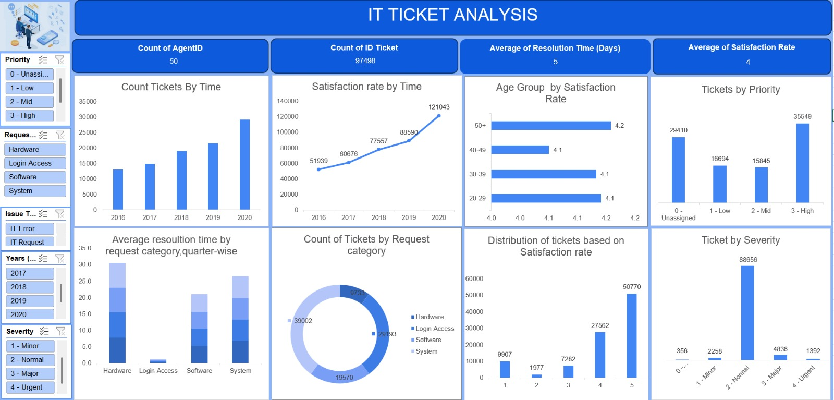

Insights:

Agent Utilization (1,950 Tickets/Agent): A primary indicator of workforce capacity. This volume highlights the balance between operational output and the risk of agent burnout, serving as a trigger for future headcount investment.
Operational Tempo (53 Daily Tickets): Establishes the baseline daily workload. This metric is essential for precision scheduling and ensuring shift coverage aligns with real-time demand.
Total Service Volume (97,498 Tickets): Reflects the cumulative scale of the IT infrastructure. This macro-view justifies long-term investments in scalable tools and departmental budget expansion.
Service Velocity (5-Day Average Resolution): Our core efficiency benchmark. Monitoring fluctuations in this metric allows us to proactively identify process bottlenecks before they impact the user experience.

Volume & Scalability

Trend: A year-over-year surge peaking at 29,088 tickets in 2020.
Strategic Insight: Support demand is accelerating faster than traditional growth models predict. This necessitates an immediate shift toward automated scaling and infrastructure enhancement to stay ahead of the curve.

Categorical Friction Points

Trend: "Hardware" and "Login Access" dominate the ticket queue.
Strategic Insight: We are spending significant manual effort on repeatable tasks. This supports a transition toward Self-Service Password Reset (SSPR) tools and specialized hardware diagnostic training to recoup lost hours.

Quality & Sentiment Maturity

Trend: CSAT has steadily climbed from 3.98 to 4.16 over five years.
Strategic Insight: Current quality assurance and training initiatives are yielding high ROI. We should double down on these programs to maintain this upward trajectory in user sentiment.

The Resolution Bottleneck

Trend: Hardware (7.63 days) and Login Access (6.62 days) are significantly lagging.
Strategic Insight: These categories are the primary drivers of our "long tail" delays. Targeted investment in diagnostic automation and dedicated workflows for these specific categories is required to lower the overall department average.

Service Inconsistency (The Polarized Gap)

Trend: A high volume of 5-star ratings contrasted by a significant cluster of 1-star ratings.
Strategic Insight: Our service delivery is currently "hit or miss." This polarization suggests that while we have high-performers, we lack standardized service protocols. A root-cause analysis of 1-star tickets is vital to eliminate recurring failure points.

Demographic Sentiment

Trend: High satisfaction in 20–29 and 50+ groups; lowest satisfaction in the 40–49 bracket.
Strategic Insight: Support is not "one-size-fits-all." We need to refine our persona-based communication to address the specific expectations and technical requirements of the 40–49 demographic.

